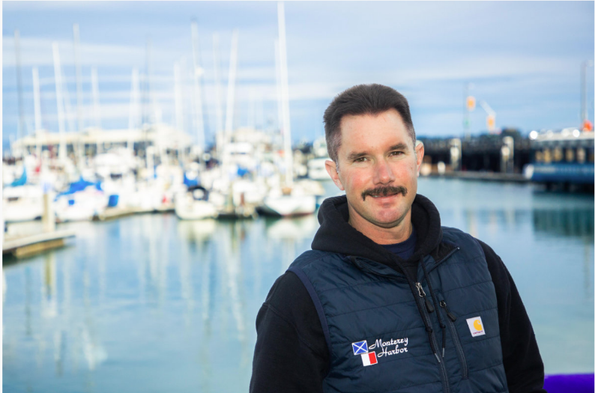
This is Jesse, he is a staff member at the Moffat Bay Marina.
Jesse’s goal is to keep long-term slip reservations organized and make sure customers are assigned to slips that fit their boats.
Jesse needs accurate reservations, slip availability, way register customer information and easy way to confirm reservations.
Photograph from Harbor and Marina staff directory, by City of Monterey (n.d.)
Jesse’s stories –
- As a marina staff member, I want to view current slip availability so that I can know which long-term slips are still available.
- As a marina staff member, I want customers to be matched with the right slip size based on the length of their boat.
- As a marina staff member, I want to see confirmed reservations so that I can track available slips and avoid double bookings.

Givnish, C. (2015, July 21). User-centered design: User personas vs. user stories. Function1.https://www.function1.com/2015/07/user-centered-design-user-personas-vs-user-stories
City of Monterey. (n.d.). Harbor and marina staff directory [Photograph]. https://monterey.gov/your_city_hall/departments/public_works/harbor_and_marina/staff_directory/index.php#prettyPhoto

